Assembly and Installation of TreePans

Congratulations on your purchase of TreePans! You are now well on your way to better watering, protecting, and maintaining your newly planted trees!

- First, gather (4) quarter sections of the TreePan and their (4) corresponding doors.

- Add doors: slightly bend up one side of the door to position the runner under the hooks. Do the same on the other side so that the door slides on the runner.

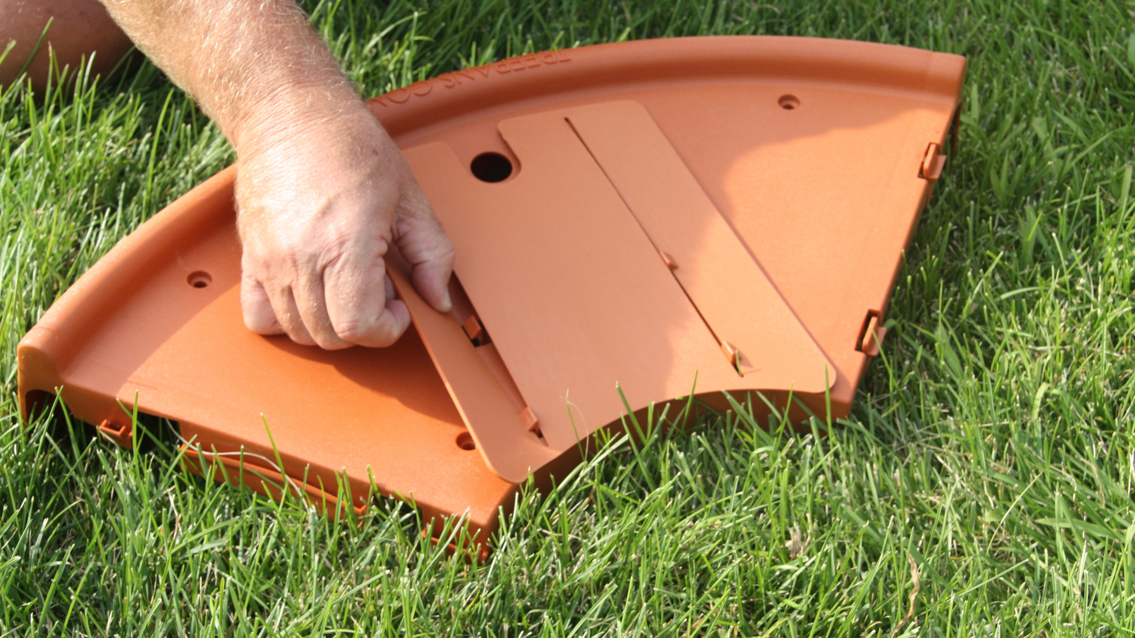

- Next, take (2) quarter sections and join them; first at the clips near the smaller end followed by the back clips located closer to the treepans.com-beveled edge. Once these two pieces have been assembled they will be referred to as a half-moon.

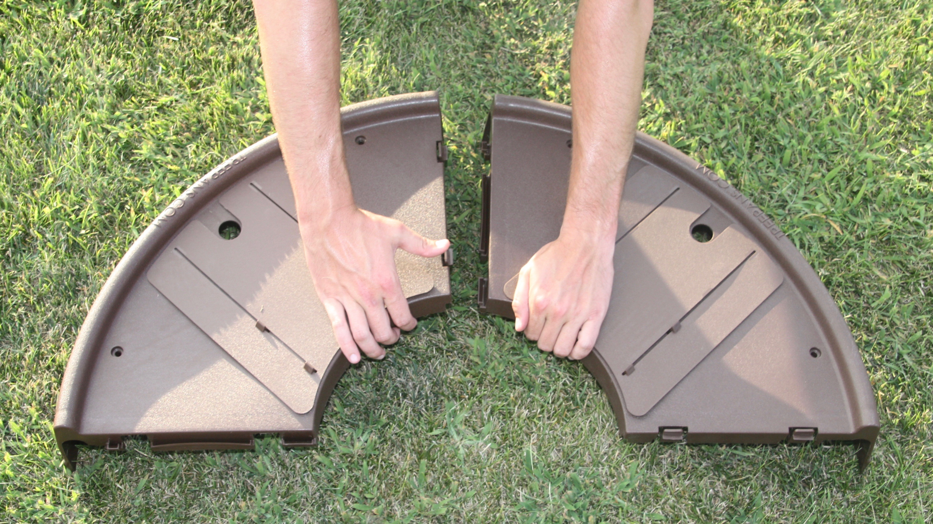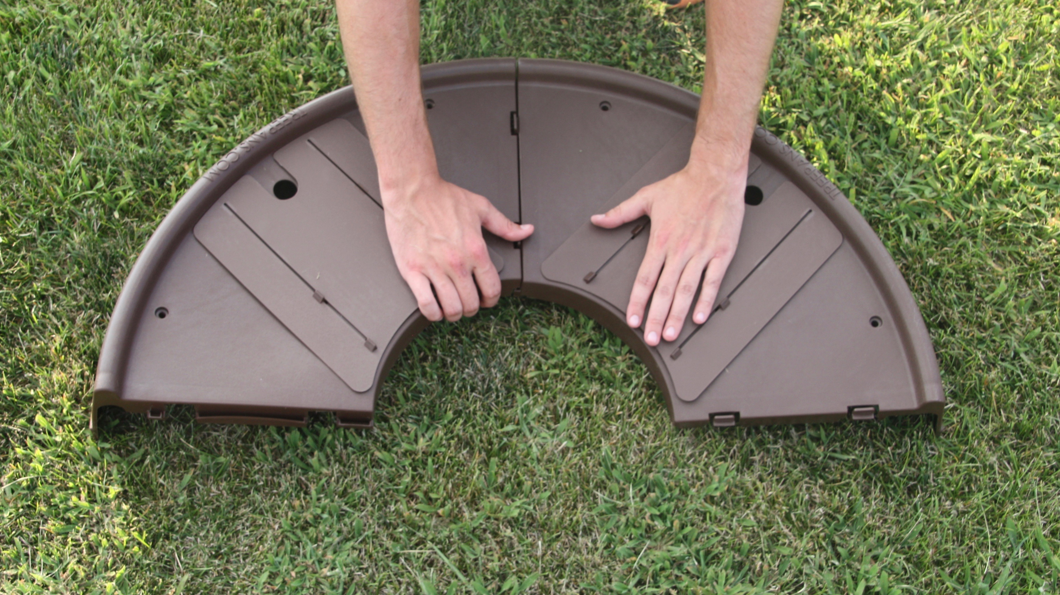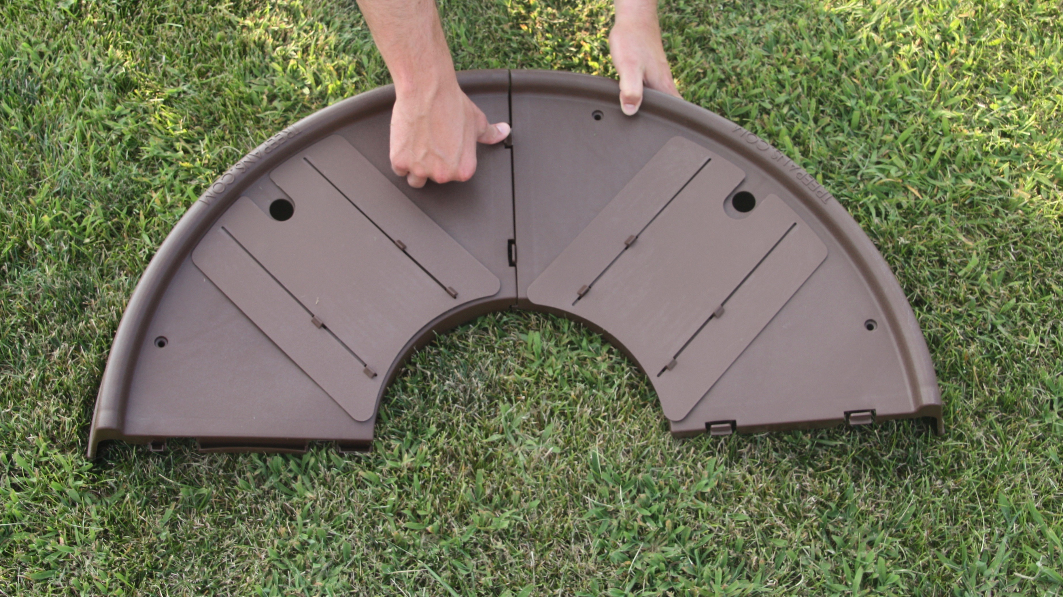

- Repeat step 3

- Now, you will take your two half-moon sections and connect each around the base of your newly planted tree. Again, start by connecting the clips closest to the small end and work your way towards the treepans.com- beveled edge.

- Collapse the doors to the trunk of the tree* to ensure the retention of moisture and the elimination of turf grass and weeds.

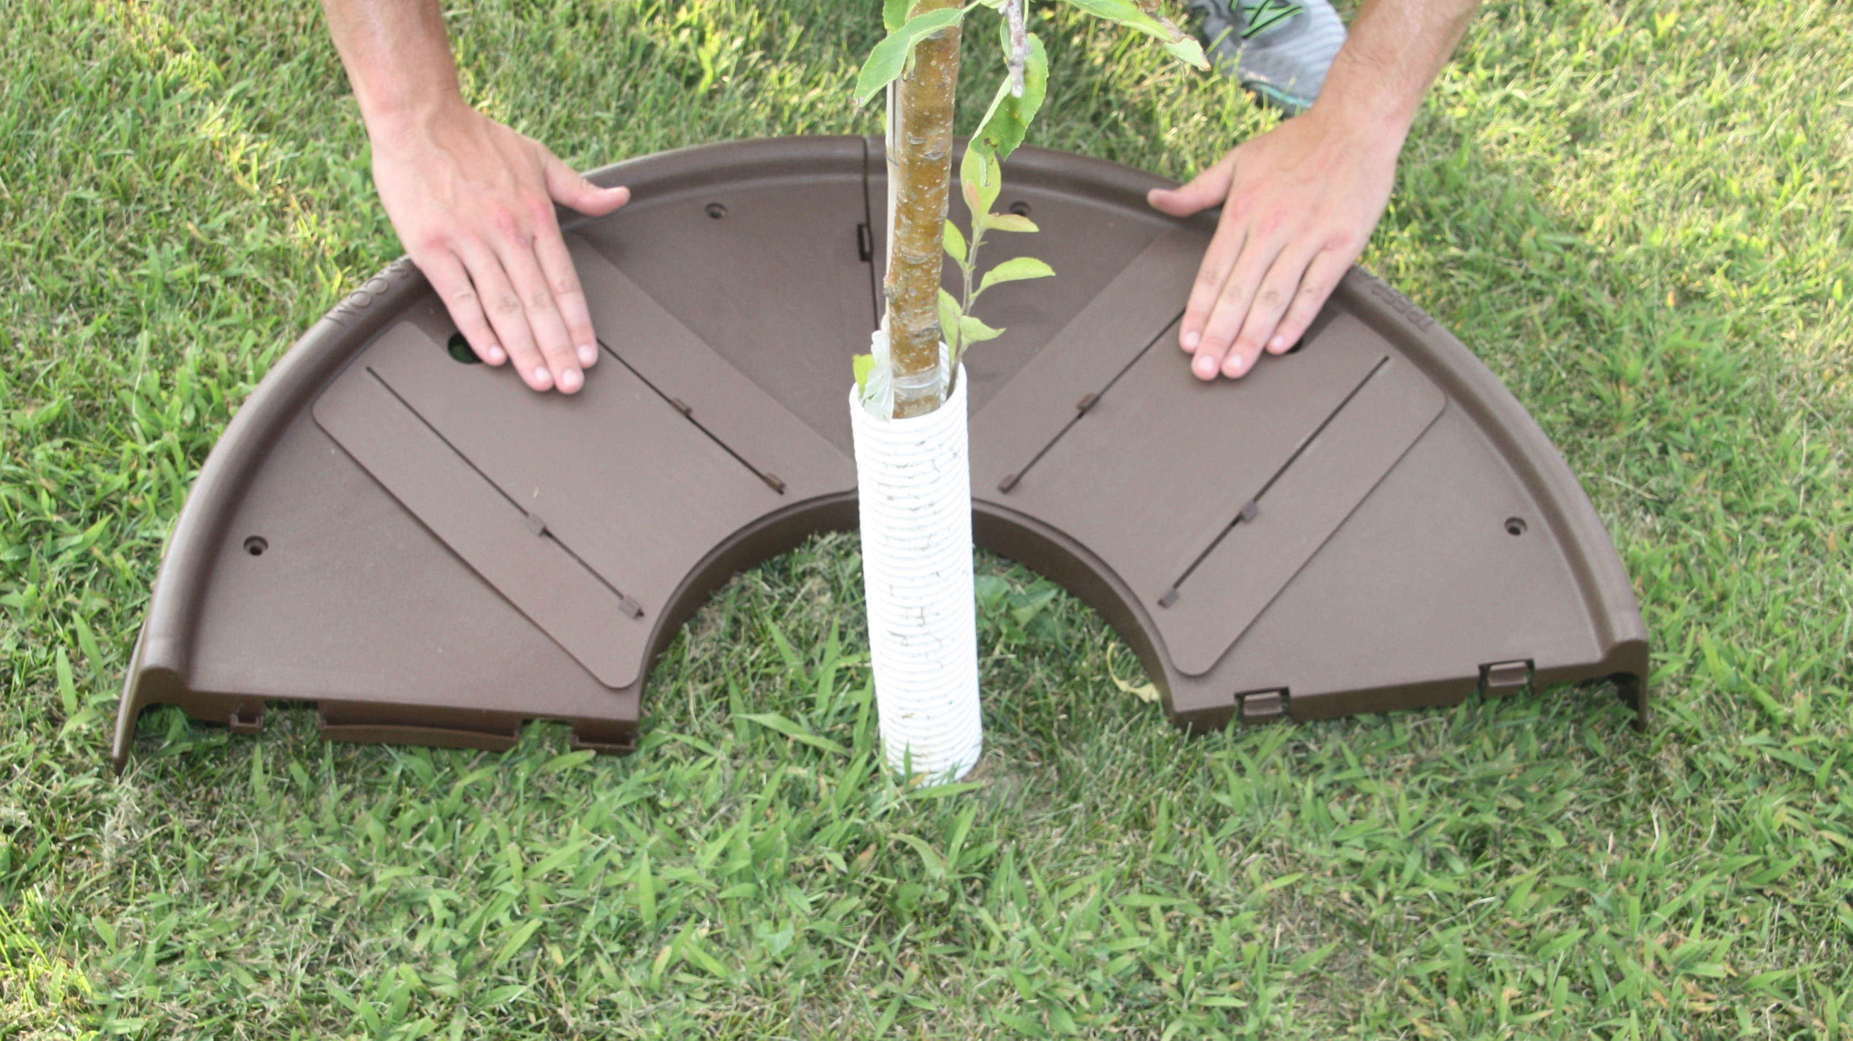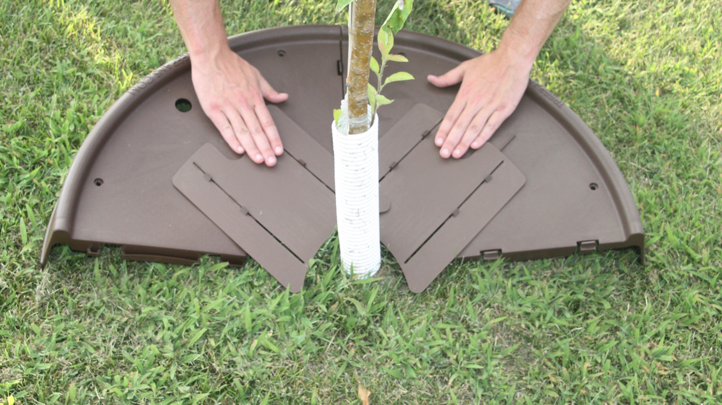

- Once the entire TreePan is secured around the base of your tree we encourage you to dig or rotate your TreePan into the loose soil 2” or up to the line located on the outer edging of the TreePan. **

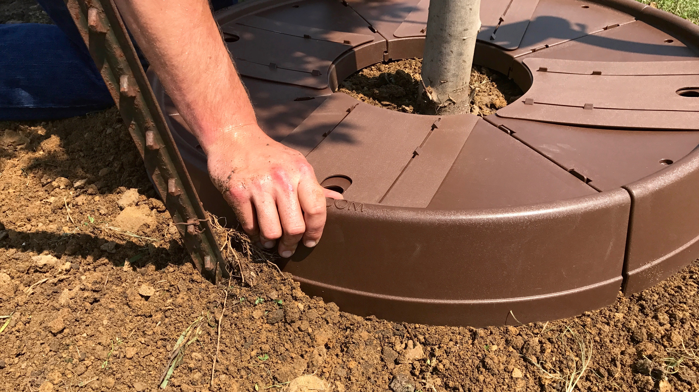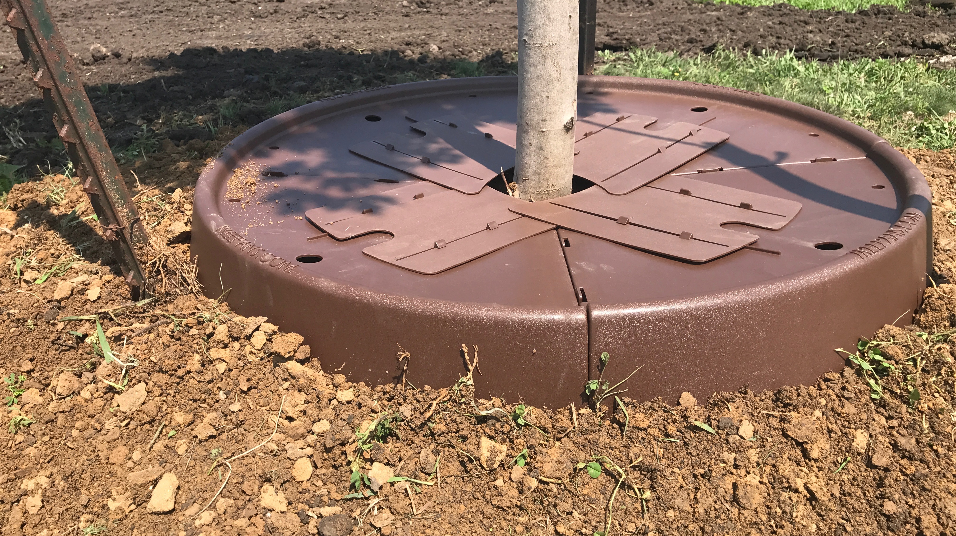

- Congratulations, your tree is now safely protected from mechanical damage, soil compaction, water runoff and MORE!

*We suggest that you leave a 1-2 millimeter gap between the trunk of the tree and the expandable doors. Although these doors are built to expand with the growth of your tree we also suggest that you check these doors with regular maintenance of your tree and adjust accordingly so they maintain a 1-2 millimeter distance from the tree.

** If installing on a hillside, align the TreePan with the outer edge treepans.com logo facing downhill to help prevent the water run-off.

We would love to see how and where you are utilizing TreePans! Please tag us on social media using @treepans or send pictures to bbrown@treepans.com.

Thank you,

